Name: ……………………………………………….. ( ) Class: ……… Date: …………………..

|  |  |  |
| --- | --- | --- |
| **1.1** | **Data Management** | **Math and Statistical Functions** |

**Math Functions**

|  |  |
| --- | --- |
| **Function** | **Syntax** |
| CEILING.MATH() | =CEILING.MATH(number) |
| FLOOR.MATH() | =FLOOR.MATH(number) |
| POWER() | =POWER(number, power) |
| SQRT() | =SQRT(number) |
| ROUND() | =ROUND(number, num_digits)  Note that num_digits is a compulsory argument. |
| RANDBETWEEN() | =RANDBETWEEN(lowest, highest) |
| RAND() | =RAND()  The RAND function has no arguments. |
| SUM() | =SUM(number1, number2, …)  Only the argument number1 is compulsory. The arguments from number2 onwards are optional.  number1, number2, etc. can be either numbers or range/cell references. |
| SUMIF() | =SUMIF(range, criteria, sum_range)  sum_range is an optional argument. |
| QUOTIENT() | =QUOTIENT(number, divisor) |
| MOD() | =MOD(number, divisor) |

**Statistical Functions**

|  |  |
| --- | --- |
| **Function** | **Syntax** |
| MAX() | =MAX(number1, number2, …)  Only the argument number1 is compulsory. The arguments from number2 onwards are optional.  number1, number2, etc. can be either numbers or range/cell references. |
| MIN() | =MIN(number1, number2, …)  Only the argument number1 is compulsory. The arguments from number2 onwards are optional.  number1, number2, etc. can be either numbers or range/cell references. |
| COUNT() | =COUNT(range1, range2, …)  Only the argument range1 is compulsory. The arguments from range2 onwards are optional. |
| COUNTA() | =COUNTA(range1, range2, …)  Only the argument range1 is compulsory. The arguments from range2 onwards are optional. |
| COUNTIF() | =COUNTIF(range, criteria) |
| COUNTBLANK() | =COUNTBLANK(range) |
| MODE.SNGL() | =MODE.SNGL(number1, number2, …)  Only the argument number1 is compulsory. The arguments from number2 onwards are optional.  number1, number2, etc. can be either numbers or range/cell references. |
| MEDIAN() | =MEDIAN(number1, number2, …)  Only the argument number1 is compulsory. The arguments from number2 onwards are optional.  number1, number2, etc. can be either numbers or range/cell references. |
| AVERAGE() | =AVERAGE(number1, number2, …)  Only the argument number1 is compulsory. The arguments from number2 onwards are optional.  number1, number2, etc. can be either numbers or range/cell references. |
| SMALL() | =SMALL(range, k) |
| LARGE() | =LARGE(range, k) |

1. Predict the resulting value of the following ceiling functions:
2. =CEILING.MATH(3.5)

……………………………………………………………………………………………………………………………………………

1. =CEILING.MATH(4.42)

……………………………………………………………………………………………………………………………………………

1. =CEILING.MATH(0.5)

……………………………………………………………………………………………………………………………………………

1. =CEILING.MATH(-0.234)

……………………………………………………………………………………………………………………………………………

1. =CEILING.MATH(-3.5)

……………………………………………………………………………………………………………………………………………

1. Predict the resulting value of the following floor functions:
2. =FLOOR.MATH(3.5)

……………………………………………………………………………………………………………………………………………

1. =FLOOR.MATH(4.42)

……………………………………………………………………………………………………………………………………………

1. =FLOOR.MATH(0.5)

……………………………………………………………………………………………………………………………………………

1. =FLOOR.MATH(-0.234)

……………………………………………………………………………………………………………………………………………

1. =FLOOR.MATH(-3.5)

……………………………………………………………………………………………………………………………………………

1. Predict the resulting value of the following round functions:
2. =ROUND(34.5, -1)

……………………………………………………………………………………………………………………………………………

1. =ROUND(4.95, 0)

……………………………………………………………………………………………………………………………………………

1. =ROUND(-0.234, 2)

……………………………………………………………………………………………………………………………………………

1. =ROUND(600, -3)

……………………………………………………………………………………………………………………………………………

1. =ROUND(0.6, 0)

……………………………………………………………………………………………………………………………………………

1. =ROUND(4.5, -1)

……………………………………………………………………………………………………………………………………………

1. =ROUND(-50.95, -2)

……………………………………………………………………………………………………………………………………………

1. For ${ax}^{2}+bx+c=0$, the values of $x$ which are the roots of the equation are given by:

$$x=\frac{-b±\sqrt{b^{2}-4ac}}{2a}$$

You are asked to use a spreadsheet to calculate the 2 roots of an equation with coefficients as given below.

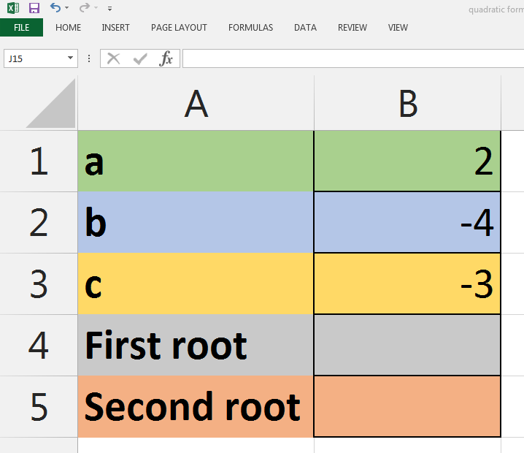

1. Suggest a formula to calculate the first root.

………………………………………………………………………………………………………………………………………………

1. Suggest another formula to calculate the second root.

………………………………………………………………………………………………………………………………………………

1. The function RAND() will generate a random number (float) greater than or equal to 0 and less than 1. In order to generate a number greater than 1, we can multiply the result of RAND() with a multiplier. For example, if we want to generate a number (float) greater than or equal to 0 and less than 10, we can use the following formula:

= RAND() * 10

You are asked to generate some random test data for weight (in float) greater than or equal to 40 and less than 70.

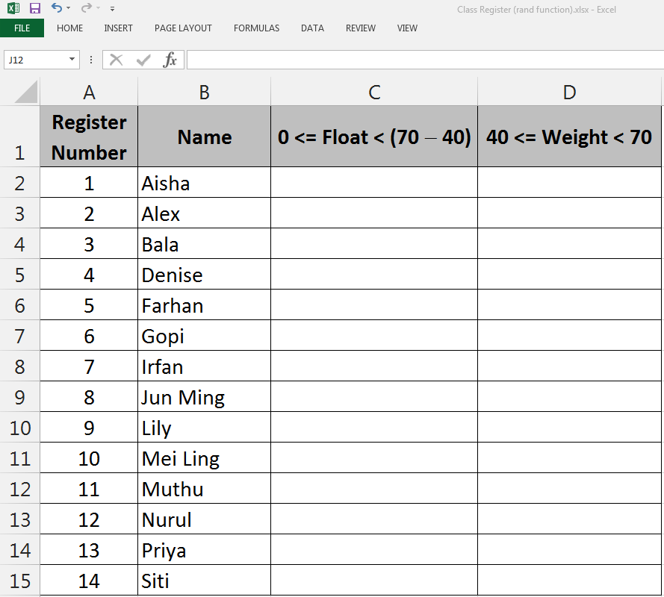

1. Suggest a formula for cell **C2** to generate random number (float) greater than or equal to 0 and less than (70 − 40).

……………………………………………………………………………………………………………………………………………

1. Suggest a formula for cell **D2** to generate random number (float) greater than or equal to 40 and less than 70.

……………………………………………………………………………………………………………………………………………

1. The function RANDBETWEEN will generate a random number (integer) between two numbers (inclusive) provided as arguments. For example, RANDBETWEEN(-5,0) will generate a number between −5 and 0 inclusive.

You are asked to create a simple dice game.

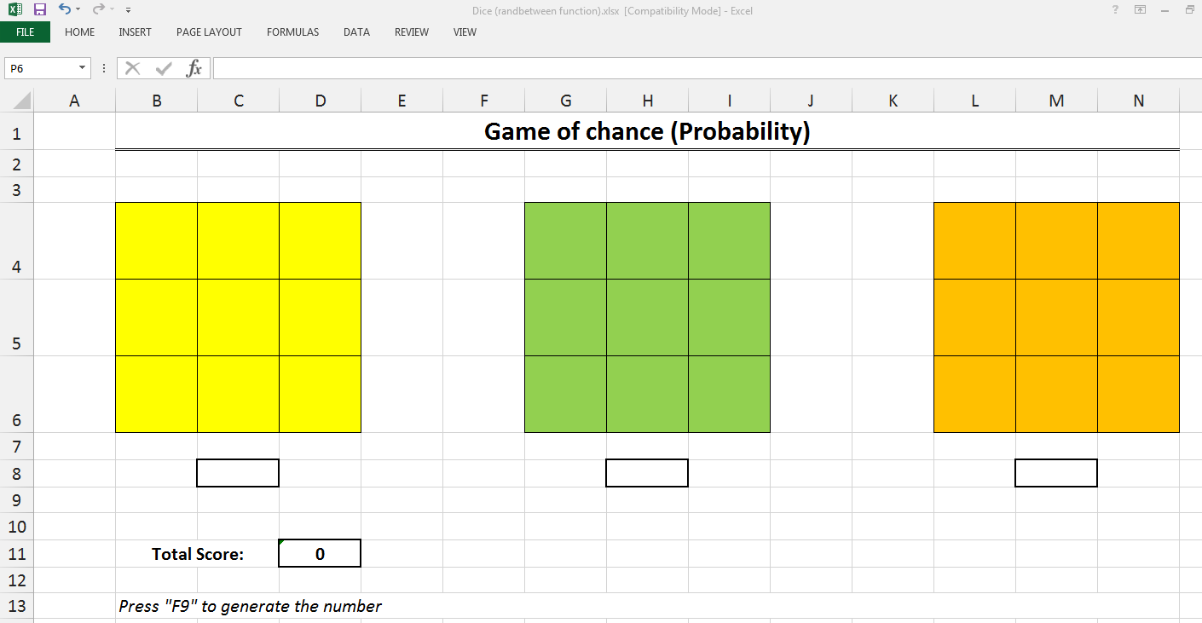

1. Suggest a formula for cell **C8**, **H8** and **M8** to generate random number (integer) between 1 and 6 inclusive.

……………………………………………………………………………………………………………………………………………

1. Suggest a formula for cell **D11** to find the sum of the three dice.

……………………………………………………………………………………………………………………………………………

1. The last digit of the 10-digit International Standard Book Number (ISBN) is a check digit that is related to the previous 9 digits by the following algorithm:
2. Multiply the first digit by 10, the second digit by 9, the third digit by 8, and so on until the ninth digit, which is multiplied by 2, then sum up the results.
3. Divide the result by 11 and keep the remainder.
4. If the remainder is 0, the check digit should be 0. Otherwise, subtract the remainder from 11. The check digit should be the resulting answer.
5. If the check digit is 10, use the letter “X” as the check digit instead.

Follow the instructions to create an ISBN check digit calculator.

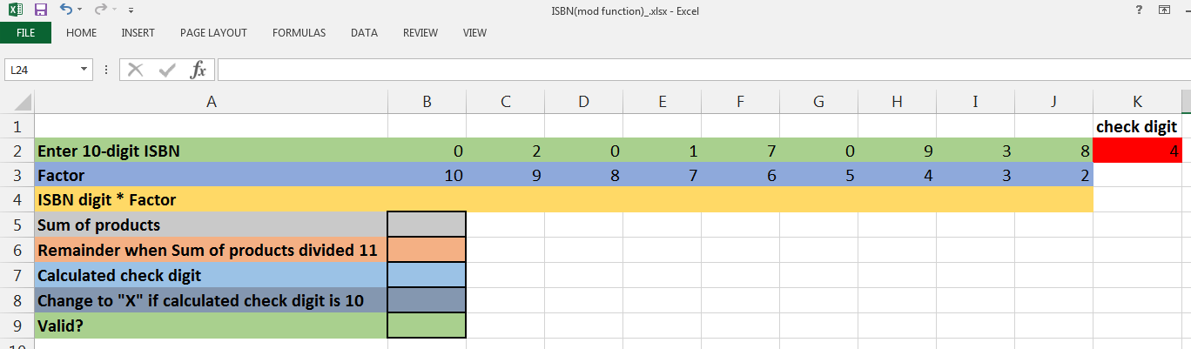

1. Open ISBN(mod function).xlsx
2. Enter formulae from **B4**:**J4** to multiply each digit of the ISBN by its factor.
3. Use the SUM() function in cell **B5** to find the sum of products.
4. Use the MOD() function in cell **B6** to find the remainder.
5. Enter a formula to find in cell **B7** to calculate check digit.  
   [Your formula should take into account the special case when remainder is 0]
6. Enter a formula in **B8** to change calculated check digit to “X” if it is 10; otherwise, **B8** will just show the calculated check digit in **B7**.
7. Enter a formula in **B9** that will show “Yes” if **B9** is equal to **K2** and “No” otherwise.
8. Enter the following ISBN from cell **B2** to **K2**.

0 4 7 1 1 9 0 4 7 0

Is it valid?

……………………………………………………………………………………………………………………………………………

1. Enter the following ISBN from cell **B2** to **K2**.

1 8 4 1 4 6 2 0 8 X

Is it valid?

……………………………………………………………………………………………………………………………………………

1. The table below shows the result of a test for a class.

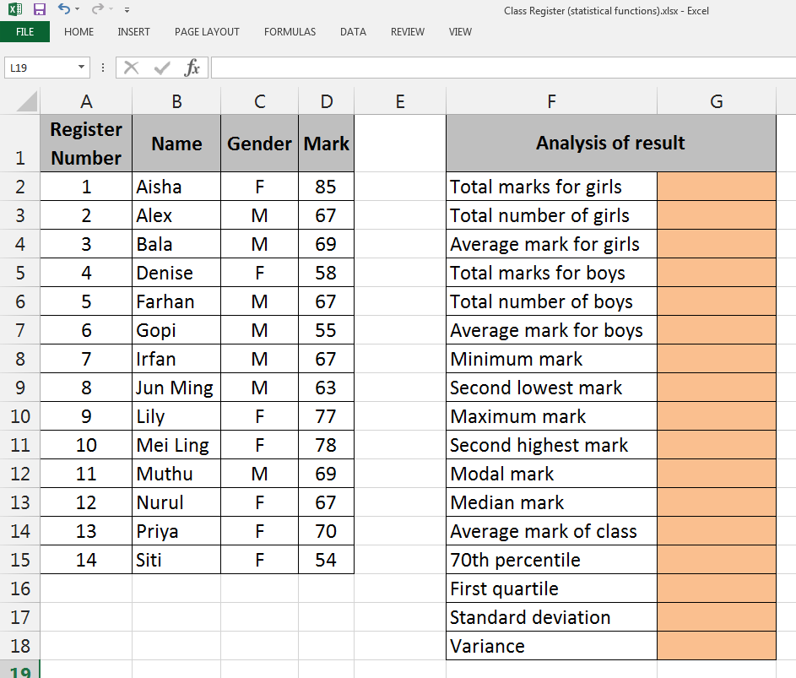

1. Suggest a formula using SUMIF() function in cell **G2** to find the total marks for girls.

……………………………………………………………………………………………………………………………………………

1. Suggest a formula using COUNTIF() function in cell **G3** to find the total number of girls.

……………………………………………………………………………………………………………………………………………

1. Suggest a formula in cell **G4** to find the average mark for girls.

……………………………………………………………………………………………………………………………………………

1. Suggest a formula using SUMIF() function in cell **G5** to find the total marks for boys.

……………………………………………………………………………………………………………………………………………

1. Suggest a formula using COUNTIF() function in cell **G6** to find the total number of boys.

……………………………………………………………………………………………………………………………………………

1. Suggest a formula in cell **G7** to find the average mark for boys.

……………………………………………………………………………………………………………………………………………

1. Suggest a formula in cell **G8** to find the lowest mark for the class.

……………………………………………………………………………………………………………………………………………

1. Suggest a formula in cell **G9** to find the second lowest mark for the class.

……………………………………………………………………………………………………………………………………………

1. Suggest a formula in cell **G10** to find the highest mark for the class.

……………………………………………………………………………………………………………………………………………

1. Suggest a formula in cell **G11** to find the second highest mark for the class.

……………………………………………………………………………………………………………………………………………

1. Suggest a formula in cell **G12** to find the modal mark for the class.

[assume data has one mode]

……………………………………………………………………………………………………………………………………………

1. Suggest a formula in cell **G13** to find the median mark for the class.

……………………………………………………………………………………………………………………………………………

1. Suggest a formula in cell **G14** to find the average mark for the class.

……………………………………………………………………………………………………………………………………………

1. The table below shows the signup form for sports day for a class.

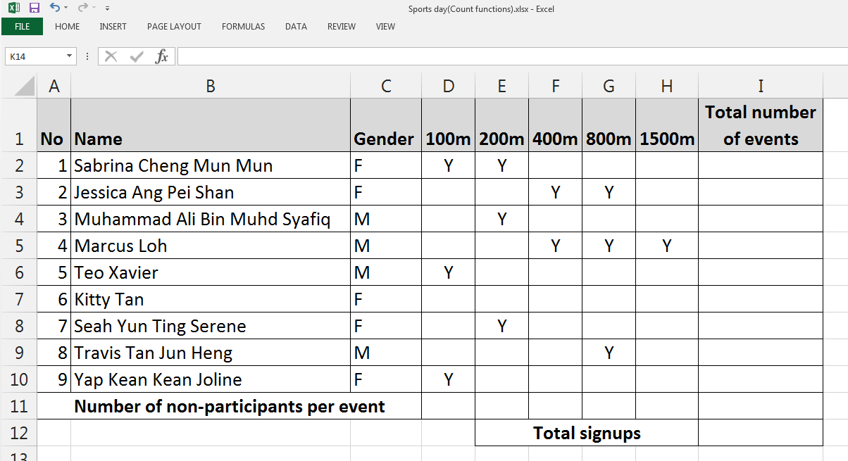

1. Suggest a formula in cell **I2** to find the total number of events Sabrina participated in.

……………………………………………………………………………………………………………………………………………

1. Suggest a formula in cell **I12** to find the total number of signups. (Assume the rest of column I has been filled in correctly.)

……………………………………………………………………………………………………………………………………………

1. Suggest a formula in cell **D11** to count how many students did not take part in 100m.

……………………………………………………………………………………………………………………………………………